UI-
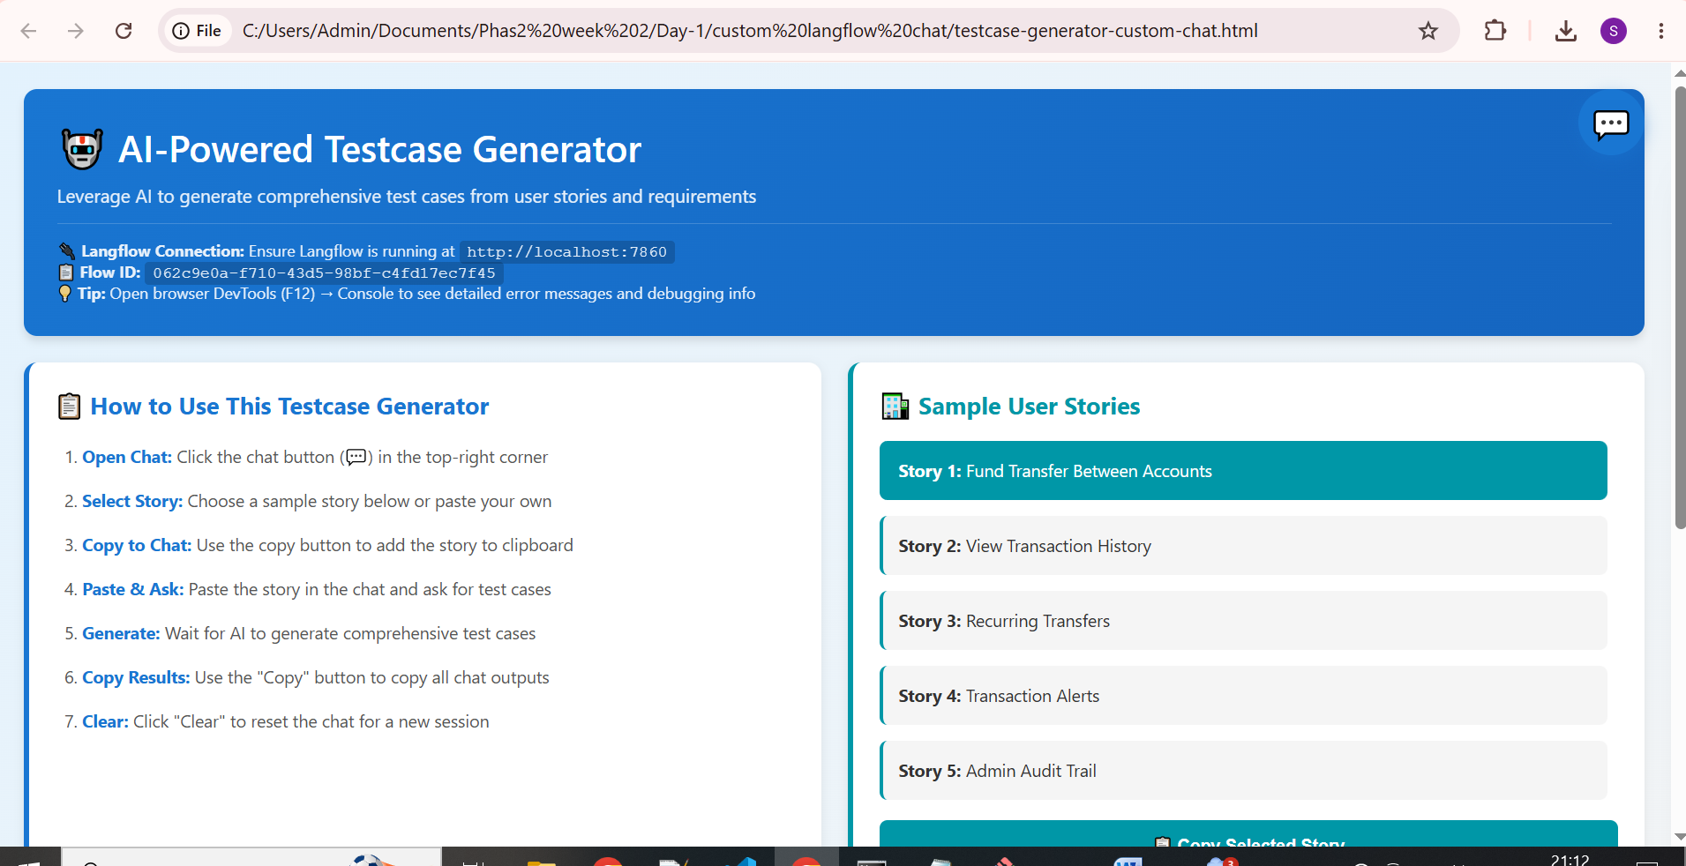

Select a userstory

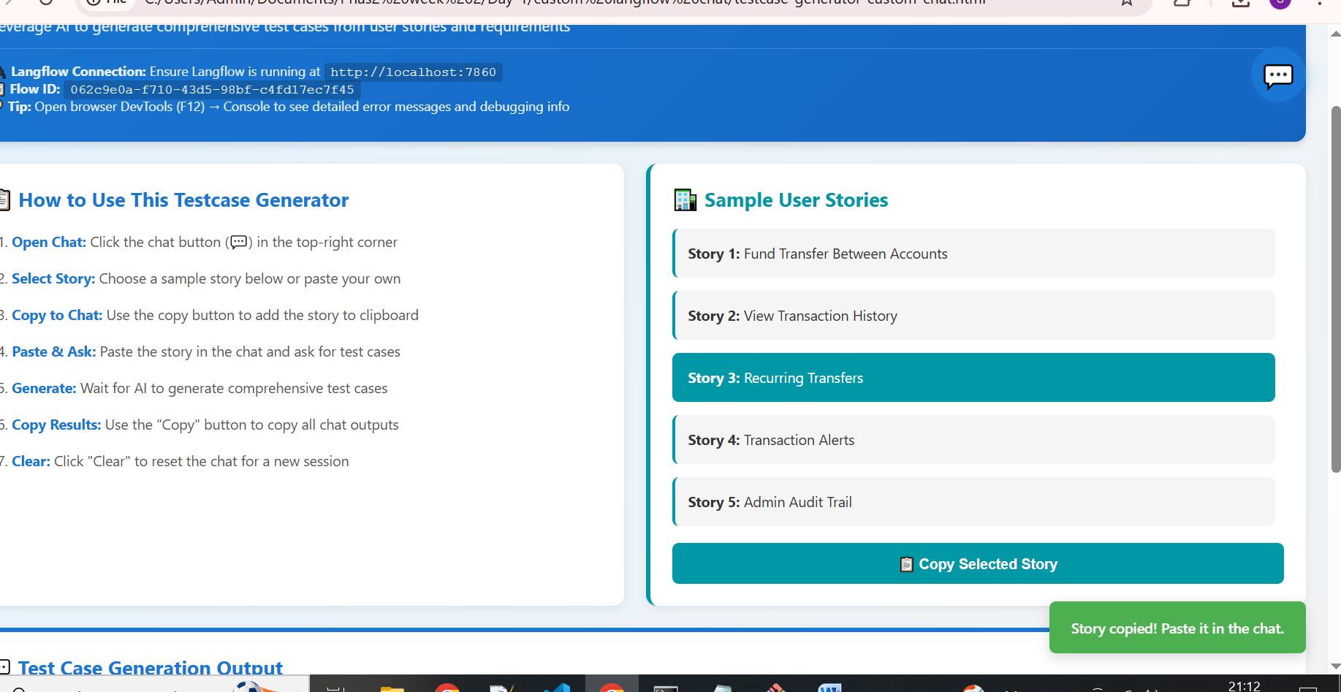

Open Ai chat assistant on right side and paste the story-

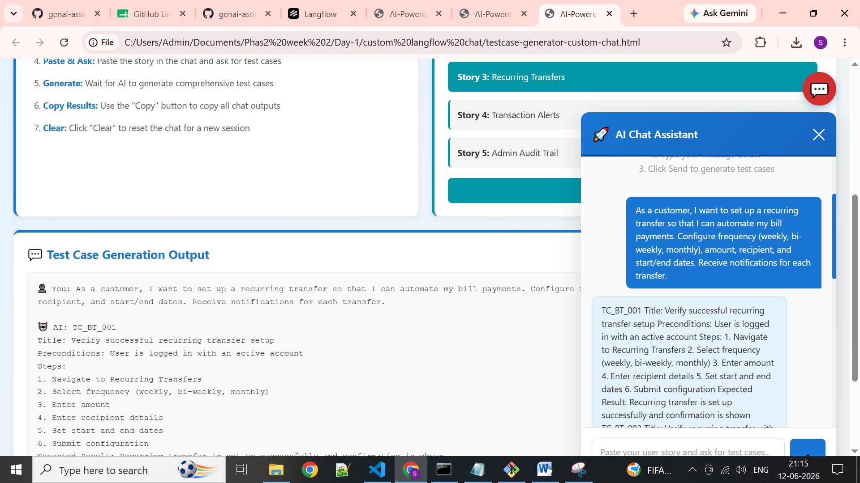

Output:
TC_BT_001 Title: Verify successful recurring transfer setup Preconditions: User is logged in with an active account Steps: 1. Navigate to Recurring Transfers 2. Select frequency (weekly, bi-weekly, monthly) 3. Enter amount 4. Enter recipient details 5. Set start and end dates 6. Submit configuration Expected Result: Recurring transfer is set up successfully and confirmation is shown TC_BT_002 Title: Verify recurring transfer with invalid frequency Preconditions: User is logged in with an active account Steps: 1. Navigate to Recurring Transfers 2. Select invalid frequency (daily, quarterly) 3. Enter amount 4. Enter recipient details 5. Set start and end dates 6. Submit configuration Expected Result: Error message is displayed indicating invalid frequency TC_BT_003 Title: Verify recurring transfer with insufficient funds Preconditions: User is logged in with an active account and insufficient balance Steps: 1. Navigate to Recurring Transfers 2. Select frequency (weekly, bi-weekly, monthly) 3. Enter amount exceeding available balance 4. Enter recipient details 5. Set start and end dates 6. Submit configuration Expected Result: Error message is displayed indicating insufficient funds TC_BT_004 Title: Verify recurring transfer with invalid recipient Preconditions: User is logged in with an active account Steps: 1. Navigate to Recurring Transfers 2. Select frequency (weekly, bi-weekly, monthly) 3. Enter invalid recipient details 4. Enter amount 5. Set start and end dates 6. Submit configuration Expected Result: Error message is displayed indicating invalid recipient TC_BT_005 Title: Verify recurring transfer notification Preconditions: User is logged in with an active account and recurring transfer is set up Steps: 1. Set up recurring transfer with notifications 2. Wait for scheduled transfer 3. Verify notification is received Expected Result: Notification is received for each transfer

